PRACTICAL NO: 01

AIM:
LOGISM ENVIRONMENT

Name: Roshan Dhaigude
Subject : Digital System & Architecture
Class: FYBsc.CS
Roll no: 64
Sign:

Aim: logisim environment

Output :

Main Screen Of Logisim
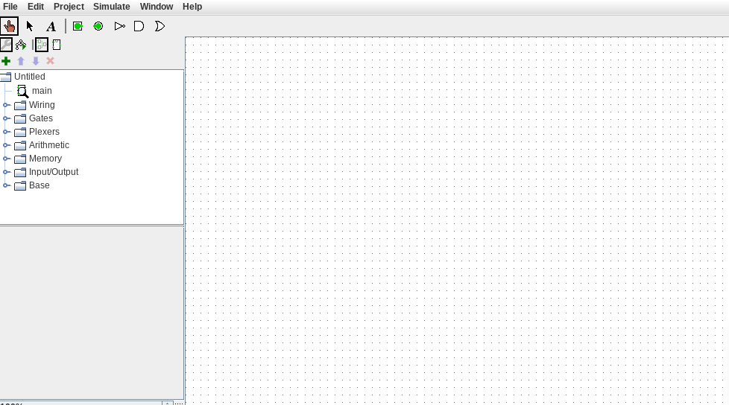

Wiring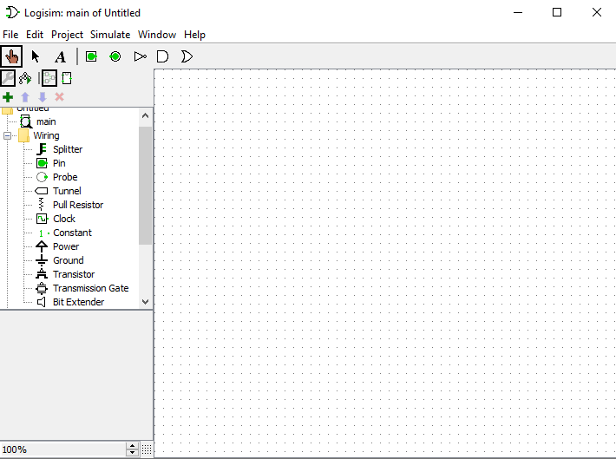

Gates
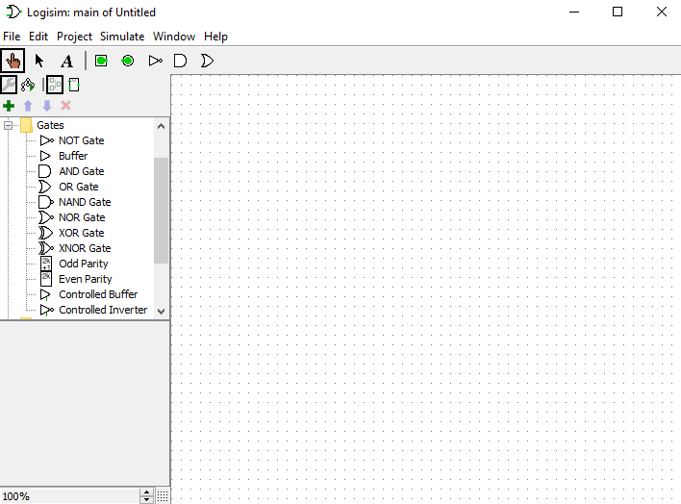

Plexers

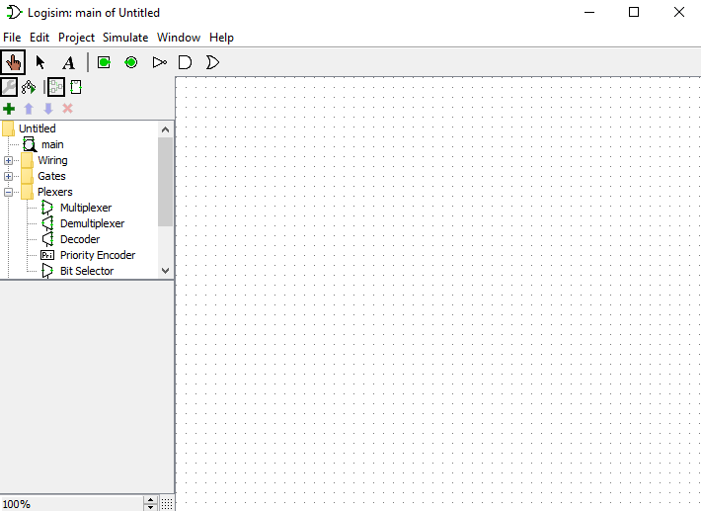

Arithmatic
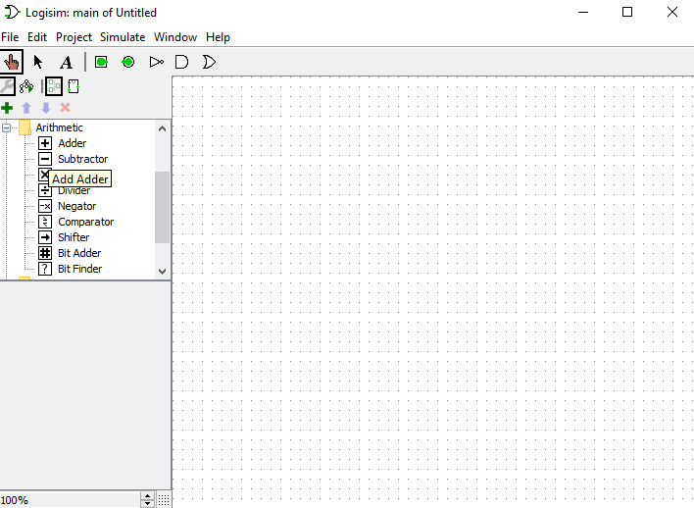
Memory

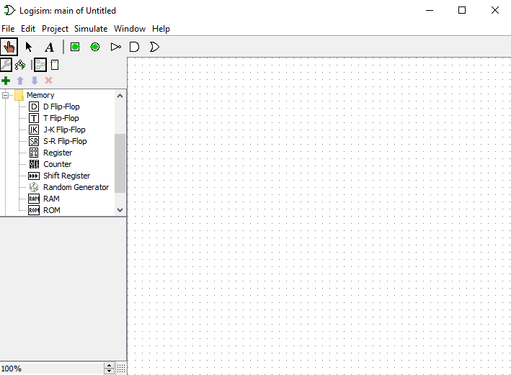

Input/output
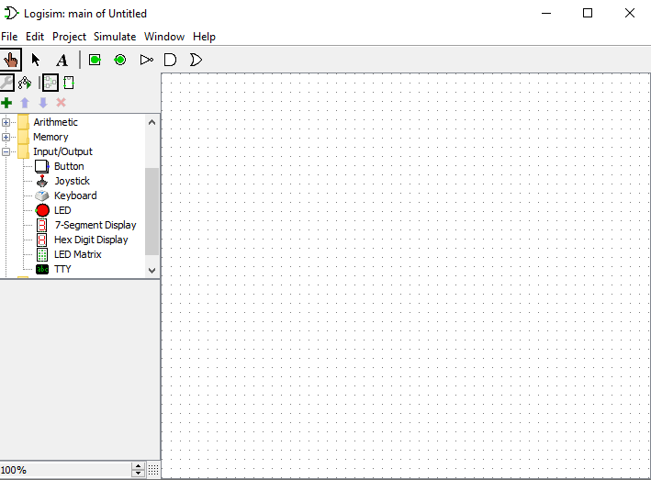
Base


